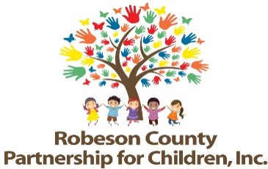

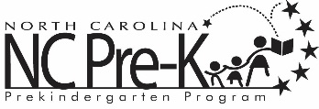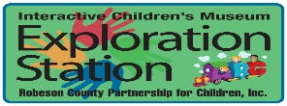



**Grants Review Committee Proposal Conference**

**January 4, 2024 9:00-5:00**

**January 5, 2024 9:00-until complete**

**Robeson County Partnership for Children, Inc. Board Room**

**210 E. Second Street**

**Lumberton, NC 28358**

RCPC advertised Request for Proposals (RFP) for the 2024-2027 grant years. Following submission deadline, the Grants Review Committee and staff conducted panel interview sessions with potential bidders. **Once panel interviews are conducted, the Grants Review Committee attends a proposal conference to review, discuss, and score proposals.**