**Robeson County Partnership for Children, Inc. (RCPC)**

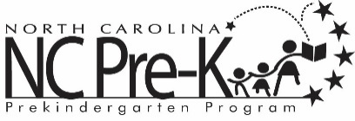

**Robeson County NC Pre-K Committee Meeting**

**October 10, 2023**

The NC Pre-K Committee Meeting scheduled for Tuesday, October 10, 2023 has been canceled.