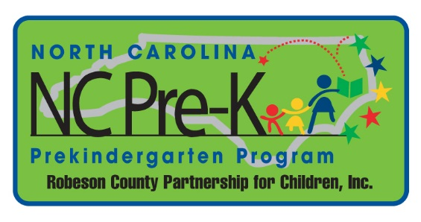
NC Pre-K Frequently Asked Questions (FAQ)

- What is NC Pre- Kindergarten? NC Pre-K provides high-quality educational experiences to enhance school readiness for eligible four year olds.
- What is RCPC?
RCPC is the Robeson County Partnership for Children. RCPC oversees NC Pre-K, Smart Start, and the Exploration Station.
- What is Smart Start?
Smart Start collaborates with local agencies to provide quality activities and resources for all children birth to five years of age, their families, and caregivers.
- What should I do in the case of inclement weather?
Follow the closing and delay schedules of the Public Schools of Robeson County. Please watch your local news for closing and delays.
- Where do I get a copy of the NC Pre-K application?
Applications are on site at the Robeson County Partnership for Children, Inc. (RCPC), request one be mailed or emailed to you, and they can be printed from RCPC website at (www.robesonpartnership.org).
- Explain the difference between NC Pre-K, Head Start and Title I? What are the requirements for each program?
NC Pre-K and Title one are both programs designed to provide high-quality educational experiences to enhance school readiness for eligible four year olds. To qualify for NC Pre-K, a family must meet 75% of the state median income. Up to 20% of children in families with family incomes above 75% of the state median income may be deemed eligible and enrolled in NC Pre-K if the child has other designated risk factors. Children of eligible military families may be served without regard to income. Students interested in Title I are given a set of tasks to complete, and are asked various questions by a certified teacher. Children are accepted depending on the results of the test. Head Start serves three and four year olds. Acceptance is based on income. Head Start can accept up to 20% of its population with over income families.
- What is the application process?
A completed application (copy of birth certificate, proof of income, and immunization records) must be submitted. Staff will approve/disapprove applications depending on documentation provided. If space is available the child will be placed at the location of choice or the site located closest to child’s home. An approval/denial letter will be mailed. Parent must confirm slot, and then the child’s information will be sent to the NC Pre-K site. The teacher will then contact the parent with further guidance.
- What are the qualifications to become an NC Pre-K teacher? Teachers should have at least a Bachelor’s degree in Birth-Kindergarten or a related field approved through DCDEE. Teachers should hold a Birth-Kindergarten licensure or be enrolled in a Birth-Kindergarten licensure program. Teachers at private day cares and Head Start have to be enrolled with the Early Education Support, Licensure, and Professional Development Unit (EESLPD). Teachers have to be approved through DCDEE prior to start date of employment.
- What is DCDEE?
DCDEE stands for the Division of Child Development and Early Education.
- What are the rates for NC Pre-K sites?
Public Schools are reimbursed up to $473.00. Head Start is reimbursed up to $400.00.
Private Day Care with a teacher with an approved Bachelor’s degree is reimbursed at $600.00. Private Day Care with a teacher with an approved Bachelor’s degree and B-K licensure is reimbursed at $650.00.
- Is transportation provided?
Students who attend public school will ride the public school buses. Students who attend day care that parents have reliable transportation will be transported by parents. Students that do not have transportation will be transported by day care vans.
- What are the hours of operation?
NC Pre-K operates from 8:00 a.m. - 2:30 p.m. NC Pre-K follows the Public Schools of Robeson County Schedule.

